Student Name | G. Manasa
Student Registration Number | 241U1R3007 | Class &Section: CSE(DS)
Study Level: UG/PG | UG | Year &Term: I & II
Subject Name | Digital Electronics

Name of the Assessment | Reflective Journal -9
Date of Submission | 7/09/2025

Reflective Journal Template
Journal Entry Guidelines | Description
1. Experience (Class Content) | Briefly describe the topics or concepts discussed during the class.
2. Feelings (Emotional Reactions) | Share your emotional reactions and thoughts during the class.  How did you feel while learning this theory?  Did the class evoke specific emotions or questions?
3. Learning (Key Insights) | Reflect on what you learned from the class.  Highlight the key insights or fundamental concepts you gained from the class.
4. Application (Practical Use) | Describe how you plan to apply the theory you've learned in real-life situations or in your academic/career endeavours.  Explain the practical utility of this theory.

Sample Journal Entry

Date | 07-09-2025
Journal Entry Topic | Sequential Logic Design-2 Registers: Buffer Register, Controlled buffer register, Shift Registers, Universal shift register.
1. Experience (Class Content) | When I first started learning about sequential logic design and especially about registers and shift registers, I honestly thought it would be a tough and dry topic. I had already studied flip-flops earlier, but I did not know how they are grouped together to make larger memory units. In class and also while reading the presentation, I saw that a register is basically a group of flip-flops combined to store multiple bits. This idea gave me a clear picture because I could imagine each flip-flop as a small box that holds a single bit, and when we place many boxes side by side, we get a register that can hold a word of data.  While going through the different types like buffer registers, controlled registers, and shift registers, I first felt a little lost because there were so many names. But slowly, with examples, I understood that they all have the same purpose to store and move data but the method of operation changes. The shift register, for example, was the most interesting for me because I could imagine how bits move step by step with each clock pulse, just like students passing a ball from one to another in a line. This visualization helped me a lot.
2.Feelings (Emotional Reactions) | At the beginning, I felt confused and nervous because the diagrams and timing diagrams looked complicated. I thought I might not be able to follow. But as the teacher explained with step-by-step examples and compared the data shifting to real-life activities. When I understood how serial-in serial-out (SISO) and serial-in parallel-out (SIPO) registers actually work. At the end of the lesson, I felt happy and confident. It gave me satisfaction because a topic that looked complex at first became clear after learning with patience.
3. Learning (Key Insights) | - Registers are simply groups of flip-flops used to store multiple bits at a time.  - Buffer registers are used for temporary storage but do not control inputs.  - Controlled registers use tri-state switches so that we can control when data is stored or read.  - Tri-state switches are special because apart from 0 and 1, they also have a high-impedance state (Hi-Z), which allows devices to share the same data bus without interfering.  - Shift registers are special types that move data either to the left or right, in serial or parallel form.  - SISO – data in serially and out serially.  - SIPO – data in serially and out in parallel.  - PISO – data in parallel and out serially.  - PIPO – data in parallel and out in parallel.  - Bidirectional – can shift both left and right.  - Universal – can do all operations (parallel, serial, shift left, shift right).  - Shifting left means multiplying by 2, and shifting right means dividing by 2 – which is a very simple but powerful logic.  - Each type of register has its advantages, disadvantages, and applications, so the choice depends on the system requirement.  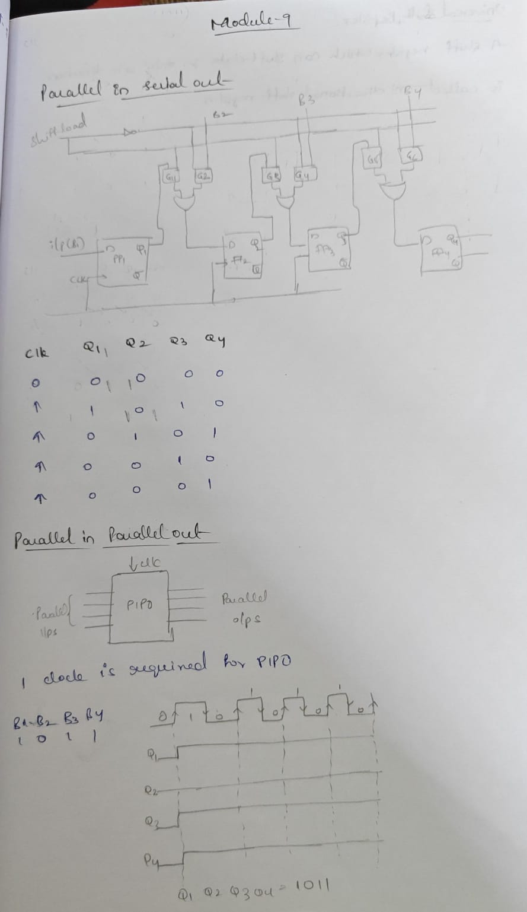
4. Application (Practical Use) | Buffer Register  Application:  Used in CPU operations to hold data between different processing stages or to synchronize signals.  Controlled Buffer Register  Application:  Essential in memory interfaces and I/O modules, allowing specific data to be written or read from memory under control of a bus or CPU.  Shift Registers  Applications:  - Data Transmission: Converting parallel data to serial for long-distance transmission or vice versa.  - I/O Expansion: Interfacing with microcontrollers to increase the number of I/O pins available for controlling devices like LEDs or reading sensors.  - Time Delays: Creating precise time delays by controlling the number of clock cycles it takes for data to pass through the register.  - Data Buffering: Temporarily holding data during processing.  Universal Shift Register  Applications:  - Data Storage: Acts as a flexible memory element within complex digital systems.  - Serial-to-Parallel and Parallel-to-Serial Conversion: Perform these conversions efficiently for communication and data processing.  - Complex Data Handling: Enables intricate operations in microprocessors and communication systems where flexible data manipulation is required.  - Shift Keys: Can be used to implement shift key functions in digital keyboards.
Conclusion | This topic gave me an eye-opening experience. At first, I only saw registers and shift registers as small theoretical circuits, but later I understood that they are the real building blocks behind computers, smartphones, and many digital devices we use daily. The most important takeaway for me was that even simple concepts like shifting bits left and right can lead to powerful applications in data storage, transmission, and processing. I also realized that being patient and breaking a difficult topic into smaller steps can change my feelings from nervousness to confidence. This lesson not only taught me technical knowledge but also improved my problem-solving attitude.

